**ACADEMIC HONESTY AGREEMENT**

I am answering this exam myself and to the best of my ability, without any assistance from other persons, materials, or resources that I am not allowed to access during the exam period. I declare that the software is fully written by me and without any assistance from my peers. I am fully aware and hereby agree to the clause that violation of this agreement is considered cheating and will result in a 0.0 for this course.

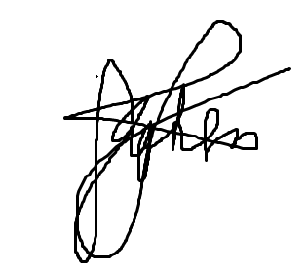

**Signature over Printed Name**